Overview
In this homework you will recreate the steps we went through on the whiteboard. You will build your Sudoku relational tables and the queries used to solve a Sudoku puzzle with a database.
You should save a copy of this file as yourname-sudoku.doc. Your answers should be copied and pasted into this document in the appropriate spaces. When you are done, create a PDF commit this one file to Git in the homework directory. Do not push your commit up to Alfalfa until the beginning of the next class.
When you copy and paste your answers, please ensure that the “Answer” text style has been applied to them. This will make your answers stand out, like this:
SELECT * FROM bcdefg
You can apply the Answer style, two ways. First, you can go to the Format menu, then Style and choose the Answer style. Second, you can open the Toolbox using the menu button, then expand Styles and choose the Answer style.

Sudoku Rules & Process
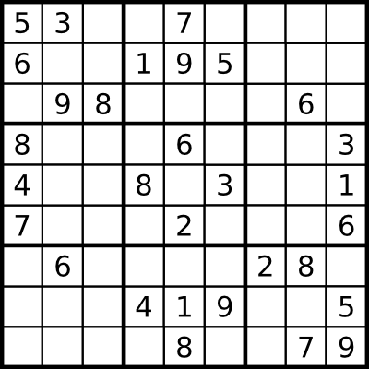
Let’s look at a generic Sudoku board. The figure to the right shows the setup: a 9x9 grid of cells, divided by darker lines into 3x3 boxes. Each cell can house a single number, or term. Some of the terms are given before the puzzle is started.
The puzzle comes from the restriction placed on the terms: Each term may be used only once for each column, row, and box. In the example figure, the 5 term given in the upper-left corner restricts the puzzle:
- We cannot use another 5 term in any of the empty cells in the top-most row.
- We cannot use another 5 term in any of the empty cells in the left-most column.
- We cannot use another 5 term in any of the empty cells in the top-left box.
This type of restriction allows us to think of cells as having possible terms. When all of the possible terms for a cell have been eliminated except one, we know that term is the solution for that cell.
Let’s look at the middle-most cell – the middle cell in the middle box, between the 6, 8, 3, and 2 terms. What can we eliminate from that cell’s possible terms?
- Given terms in the same column (above and below) eliminate 1, 2 6, 7, 8, and 9.
- Given terms in the same row (left and right) eliminate 1, 3, 4, and 8.
- Given terms in the same box (within the heavy lines) eliminate 2, 3, 6, and 8.
Since we are using the numbers 1-9 as our terms, we have eliminated all possible terms except 5, which becomes our solution for that cell. That 5 term then eliminates any other possible 5 terms in the same row, column, and box. Solving the puzzle is the process of eliminating possible terms until every cell has a known term.

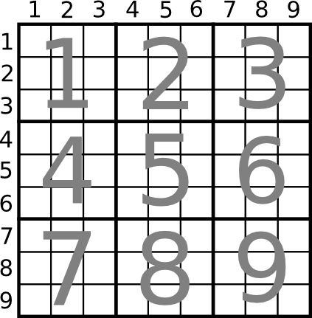
Modeling a Sudoku Board
How can we model a Sudoku puzzle in a relational database? We need to break the puzzle board down into its basic elements. The rules place restrictions on the column, row, and box for each cell, so that’s a good place to start. We’ll use a numbering scheme such that each column, row, and box are numbered. Columns are numbered left to right from 1, rows from top to bottom from 1, and boxes from top-left to bottom-right from 1.
Create a table named “sd_terms” with a single integer column term. This will be our Numbers table—from here we can build everything else. Make sure you make the term column the primary key, and that the engine is set to InnoDB. Insert the values 1-9 into this table.
create table sd_terms (
term int not null primary key
)engine=innodb;

insert into sd_terms (term)
values (1),(2),(3),(4),(5),(6),(7),(8),(9);
The number of terms on a Sudoku board is the same as the number of rows and columns. We can then represent our board structure as a view on top of our terms table. To do this, we need to cross join our terms table with itself—making a Cartesian Product—to get every combination of row and column. The left terms table can be the row number, while the right terms table can be the column number.
But there’s one more trick: we need to get the box number. We can cheat with a standard 9x9 Sudoku board by using a bit of math:
Box = 1 + (FLOOR((Row – 1) / 3) * 3) + FLOOR((Col – 1) / 3)
Create a query to represent a Sudoku board, with columns row, col, and box, by joining the terms table to itself and using the formula above.
Create view sd_board as
select
sd_terms1.term as row,
sd_terms2.term as col,
1 + (FLOOR((sd_terms1.term - 1) / 3) * 3) + FLOOR((sd_terms2.term - 1) / 3) as box
from sd_terms as sd_terms2
cross join sd_terms as sd_terms1;
Your query should return 81 records. Save that query as a new view named sd_board.
We should sanity-check our board before we continue, to be sure we performed the join correctly. Each box should have exactly 9 cells. We can verify this by running a SELECT on our sd_board view, getting a count of cells per box, and filtering out any boxes that have exactly 9 cells. Write this query.
select *
from sd_board;
Run this query to ensure that your board is well-formed. If it is, you shouldn’t get any results from this query.

Modeling Sudoku Cell Solutions
We need a table to store the values for the cells with given solutions. Create a table called “sd_givens” which can hold a cell’s row, col, box, and term. Ensure that the table’s primary key is the combination of col and row number.
create table sd_givens(
row int not null,
col int not null,
box int not null,
term int not null,
primary key(row, col)
)engine=innodb;
Referring back to the figures on the Page 1, insert records into your sd_givens table for each of the given terms on that board. You should have 30 records when you are done.
We also need a table to store cell solutions that we figure out ourselves. We don’t want to put them in our sd_givens table, as we want to keep our given values separate from our solved values. Create another table “sd_solutions” with the same structure and keys as sd_givens.
- note: must enter these by hand (all 30)
create table sd_solutions(
row int not null,
col int not null,
box int not null,
term int not null,
primary key(row, col)
)engine=innodb;
This keeps our givens separate from our solutions, but it creates a problem: we now have two tables that provide pieces of the same information. We should create a view that lets us query both tables as if they were one. Since both tables have parts of the data, but not inter-related records, we should use a union instead of a join. Create a view named “sd_knowns” which unions the two tables, one atop the other.
create view sd_knowns as
select row, col, box, term
from sd_givens
union all
select row, col, box, term
from sd_solutions;
We need a way to keep track of the possible terms left for our cells. If we start with an empty board, each of our 81 cells has possible terms 1 to 9, for a total of 729 starting possible terms. Create a table “sd_possible” to hold this information. It has the same form as our sd_givens and sd_knowns, but since we have more than one term per cell we need to expand the primary key to include not just the col and row but also the term.
create table sd_possible(
row int not null,
col int not null,
box int not null,
term int not null,
primary key(row, col, term)
)engine=innodb;
We need to populate our sd_possible table with all 729 possibilities in an empty board. Instead of doing this by hand, let’s use a numbers table to help us out. We already have our 81-cell board map in our sd_board view, so we can expand this out with each of the 9 terms by cross joining our sd_board with our sd_terms Numbers table.
insert into sd_possible
select a.term as row, b.term as col,
1 + (FLOOR((a.term - 1) / 3) * 3) + FLOOR((b.term - 1) / 3) as box,
c.term as term
from sd_terms a
cross join sd_terms b
cross join sd_terms c;
We should sanity-check this data, too. Write a query, similar to the sanity-check query above, that finds cells that do not have exactly 9 distinct terms in them.
select row, col, count(*) as c
from sd_possible
group by row, col
having (c = 9); - note: think this should be != or <>
Run this query to ensure the integrity of your possible terms.

Solving a General Sudoku Puzzle
Solving the puzzle involves eliminating possible terms from sd_possible until each cell has only one possible term. We can eliminate possible terms by looking at our knowns and following the rules: each term must be unique in its column, row, and box. For now, let’s work on just one of the rules: eliminating possible terms in a given row.
Write a SELECT query to fetch all of our known values from sd_knowns joined to our possible terms in sd_possible, focusing on where the row and term are the same.
select p.row, p.col, p.box, p.term
from sd_possible as p
left join sd_knowns as k
on (p.row = k.row) and (p.term = k.term);
We can extend this SELECT query to include not just matches of the row and term, but also of the column and term, and then the box and term. Be sure to use correct parenthesis groups so that your Boolean statements do not get confused.
select p.row, p.col, p.box, p.term
from sd_possible as p
left join sd_knowns as k
on (p.row = k.row) and (p.term = k.term)
or (p.box = k.box) and (p.term = k.term);
Finally, we can extend this query one more time to eliminate all possible terms for a cell where we have a known value. This involves joining on the column and row, and can be another OR statement like those above.
select p.row, p.col, p.box, p.term
from sd_possible as p
left join sd_knowns as k
on (p.row = k.row) and (p.term = k.term)
or (p.box = k.box) and (p.term = k.term)
or (p.col = k.col) and (p.term = k.term)
We now have a query that gets us all the possibilities that can be eliminated, based on the rules of Sudoku. But we’re not interested on what can be eliminated—we’re interested in what’s left after the eliminations. To find out what’s left, we need to invert the query—we need to rework our join to find things that don’t match.
Our current query uses an INNER join to find the matches between our knowns and our possibilites. To invert this, we can change our query to use a LEFT join, make the possibilities the left table, and look for right-side NULL values in our knowns table. Create a query that does this, showing only possibilities that haven’t been eliminated.
- note: can sort by column from the drop down menu. This will allow the user to read only a couple columns
select p.row, p.col, p.box, p.term
from sd_possible as p
left join sd_knowns as k
on (p.row = k.row) and (p.term = k.term)
or (p.box = k.box) and (p.term = k.term)
or (p.col = k.col) and (p.term = k.term)
or (p.row = k.row) and (p.col = k.col)
where(k.term is null)
The first time you run it before finding any new solutions, this query should return 153 records. We started with 729 possibilities, so this is quite a reduction! Save this query as a new view named sd_reduced.
We should now check to see if that uncovered any new solutions. Cells with solutions are the ones where there is only a single term left. We can find these by obtaining a count of terms for each combination of col, row, and box and then filtering down to only the records with a single term. Write the SELECT query over your sd_reduced view to find these new solutions. Make sure your result set returns the row, col, box, and term for the solution.
select col, row, box, count(term) as term
from sd_reduced
group by col, row, box
having (term = 1)
The first time you run this, you should get 4 solutions. We should put these terms into our sd_solutions table. Add the INSERT clause to the previous SELECT statement to do this.
select
p.row AS row,
p.col AS col,
p.box AS box,
p.term AS term
from sd_possible p
left join sd_knows k
on (p.row = k.row) and (p.term = k.term)
or (p.box = k.box) and (p.term = k.term)
or (p.col = k.col) and (p.term = k.term)
or (p.col = k.col) and (p.row = k.row)
where k.row is null;

insert into sd_solutions
select a.row, a.col, a.box, a.term
from sd_reduced a
join (
select col, row, box, count(term) as term
from sd_reduced
group by col, row, box
having (term = 1)
) as b
where a.col = b.col
and a.row = b.row
and a.box = b.box;

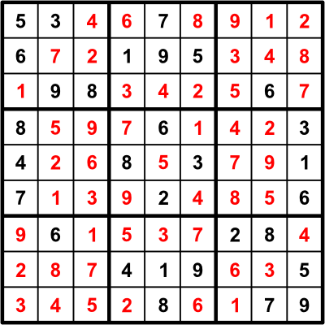
As we are using a view to combine our solutions and givens into a unified view of all knowns, adding solutions to the sd_solutions table makes them automatically show up in the sd_knowns view. Since the sd_reduced view builds on the sd_knowns view, it will automatically reduce our possibilities as new knowns are added from the new solutions. In effect, we’ve made the solution feed back into itself, just like the game does.
We can solve our puzzle by repeating the INSERT statements until no more possible terms are reduced and no more solved cells are inserted. Solve your puzzle by repeating this query until your sd_knowns view has all 81 cells in it. Your solution should match the solution to the right.

We use the word term because some variants of Sudoku might use letters or pictographs instead of numbers.

